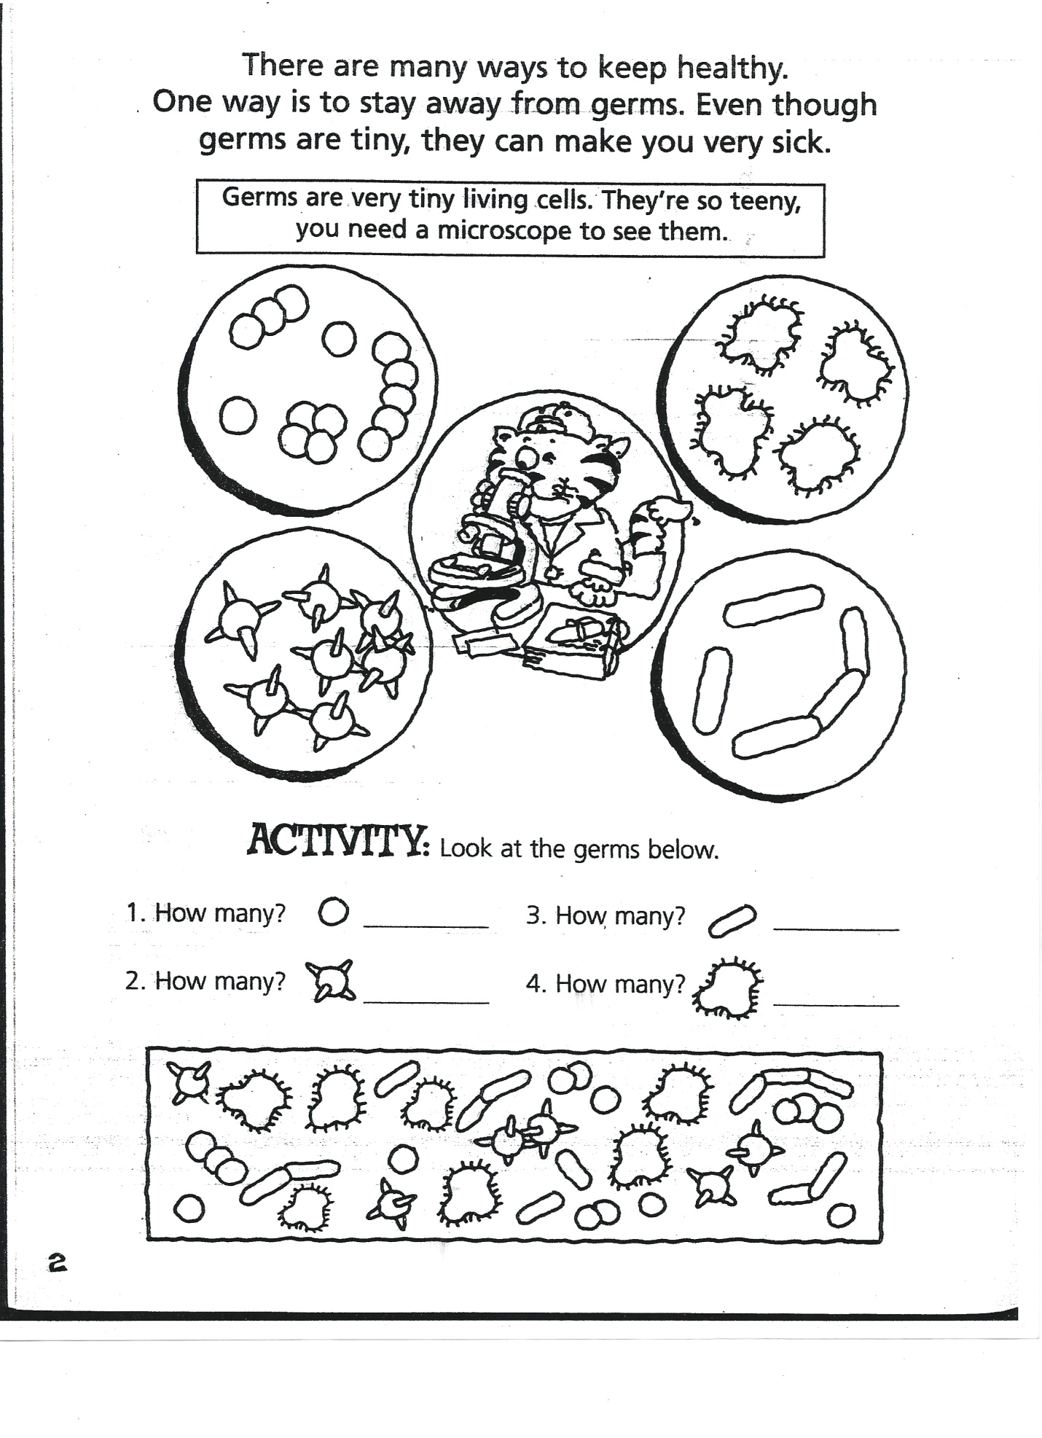

Song
Sung to Row, Row, Your Boat

Brush, Brush, Brush your teeth, at least two times a day.
Cleaning, Cleaning, Cleaning, Cleaning, fighting tooth decay.
Floss, Floss, Floss your teeth, every single day.
Gently, Gently, Gently, Gently, whisking plaque away.
Rinse, Rinse, Rinse your teeth, every single day.
Swishing, Swishing, Swishing, Swishing, fighting tooth decay.

Tooth Detective
What you need: Styrofoam plates, scissors, pen and paper.
What to do:
- Cut the Styrofoam plate in 4 equal pie pieces. Two plates are enough for 4 students.
- Place 2 pieces together, one on top of the other. Cut the “point” off both pieces.
- Put the cut ends of the 2 pieces into your mouth. Push pieces in as far as possible while still being comfortable.
- Bite down on the pieces firmly and remove them.
- Use the pen to label the upper piece “Top Teeth” and the lower piece “Bottom Teeth”.
- Examine the teeth impressions. Answer these questions on a piece of paper. How many teeth are there in the top impression? How many teeth are in the bottom impression? What features of the impressions are useful to tell the top teeth from the bottom teeth? How are the teeth different? Is there anything special about them?

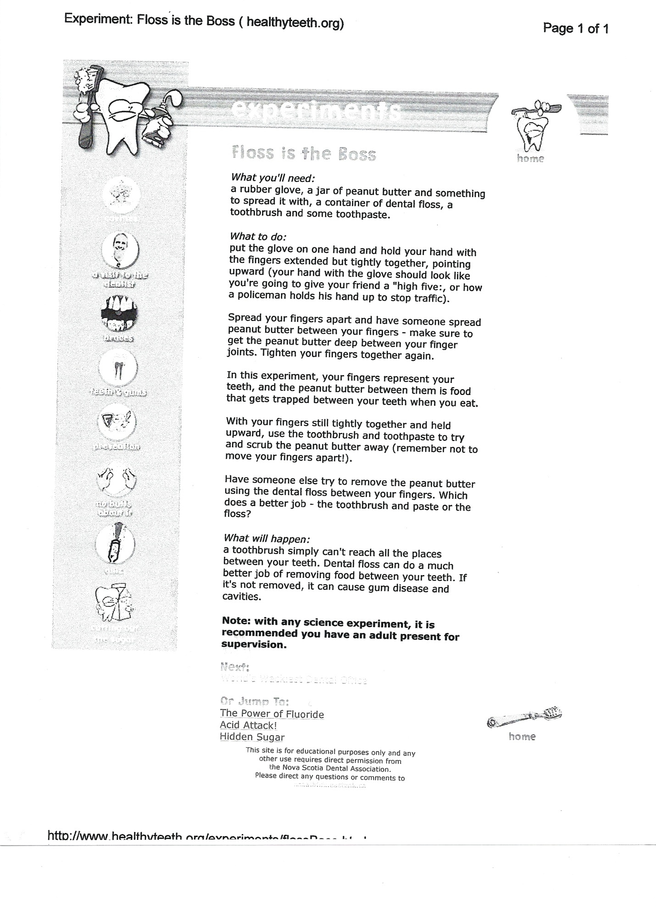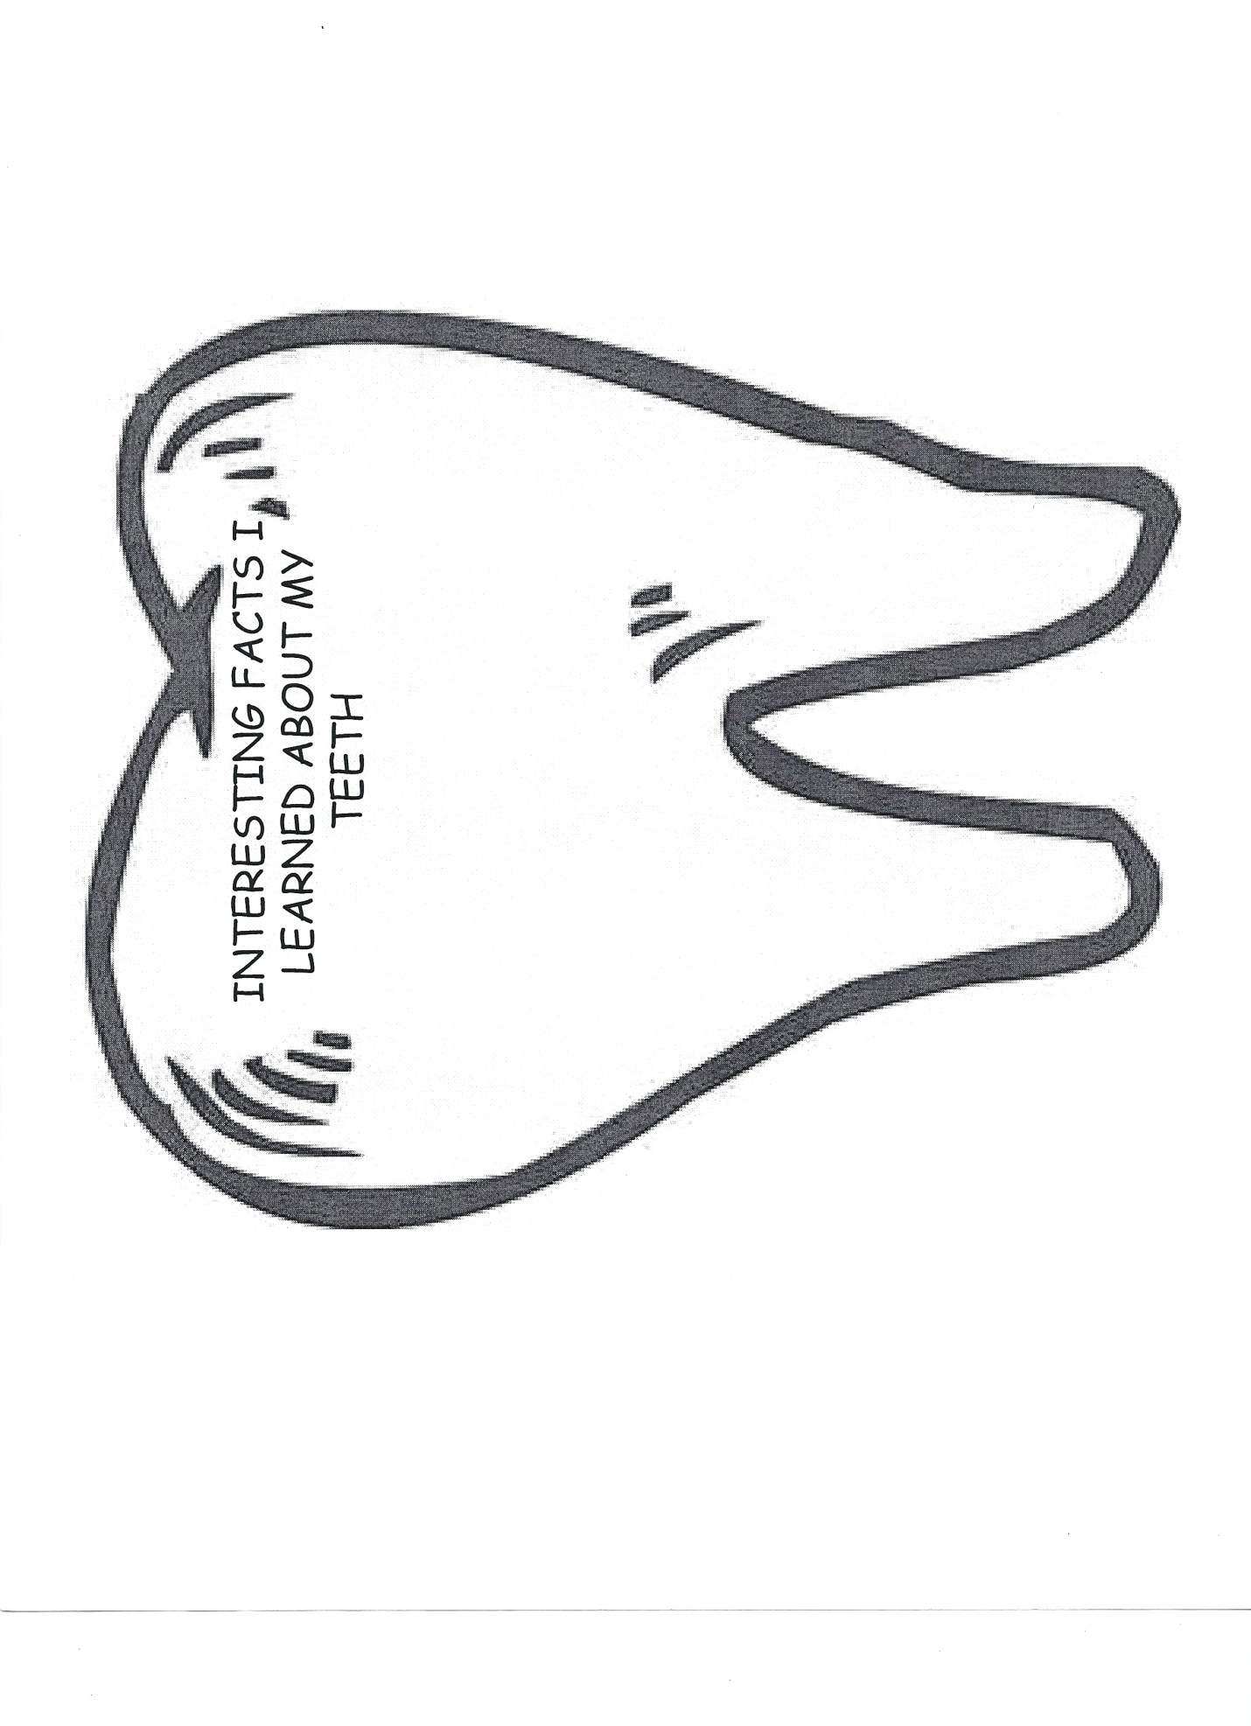
Paper Plate Mouth
Supply each child with a small paper plate and tiny marshmallows. Have the children glue the marshmallows around the edge (for teeth). When the glue has tried, fold the plate in half.

Self Esteem Resources
“I Like Myself!” by Hans Wilhelm
“I Won’t Share” by Hans Wilhelm
“I Hate Bullies” by Hans Wilhelm
“How Are You Peeling? Foods with Moods by Saxton Freymann and Joost Elffers

Tobacco
What you need:
A clear plastic bottle with a narrow neck (e.g., a small soft drink, juice, or spring water bottle)
- cotton balls
- modeling clay
- a pencil
- a cigarette
- matches
- writing paper
- pencils or pens
Lesson Plan
- Perform this demonstration for students to observe because it involves matches and a cigarette.
- Start the demonstration by offering a handful of students an opportunity to drop a cotton ball into the plastic bottle. Then create a ball of modeling clay and block the mouth of the bottle with it. Use a pencil to poke a hole through the modeling clay until you see the pencil tip inside the bottle; then remove the pencil.
- Stick one end (the filtered end, if you are using a filtered cigarette) into the hole created in the modeling clay. Light the cigarette.
- Now gently squeeze the plastic bottle to simulate breathing. Squeezing the bottle draws cigarette smoke inside the bottle the way lungs draw smoke into the body. You might let students take turns squeezing the bottle.
- After pumping the bottle a dozen times or so, extinguish the cigarette. Then remove the clay plug. Ask students to observe the cotton balls in the bottom of the container.
- Lead a discussion with the following questions: What happened? How do the cotton balls look? Why do they look that way? How does this demonstration show the potential effects of smoking on the body? Ask students to write a brief summary of the demonstration and what they learned.
Lung Activities
What you need:
Plastic Water Bottles
Square piece of plastic (trash bag)
Masking Tape
Balloon
Rubberbands
Cut the bottom of the bottle off. Make a tag with the masking tape in the middle of your piece of plastic. Place the plastic piece over the end of the bottle and secure with the rubberband. Put the balloon inside of the bottle covering the bottle opening. Blow a little air into the balloon. Pull on the bottom tab and push in, this will inflate and deflate your lung (balloon).

Plastic Baggies
Coffee Stirrers or Small Straw
Cut out of a pair of lungs
Put your lungs inside the baggie and the straw and seal. Students inflate and deflate their baggie like lungs.

Nutrition
www.myplate.gov
www.huffingtonpost.com/food
http://fnic.nal.usda.gov/nal_display/index.php?info_center=4&tax_level=3&tax_subject=256&topic_id=1348&level3_id=5732
www.futp60.com

You Are What You Eat
What you need:
Food labels
Cubes that represent “fat” grams
Sugar packets or sugar cubes representing “sugar” grams
What to Do:
Place the food items on a table. Have the students identify the amount of “fat" and “sugar” grams for each item, by reading the food label. Have the students arrange the food items according to the healthiest to the least healthy.

General Health Resources and Books
Inside Your Outside All About the Human Body by Tish Rabe
Oh, the Things you can Do that are Good for You by Tish Rabe
Power Panthers Implementation Manual, Child Nutrition and Wellness, Kansas State Department of Education. www.kansasteamnutrition.org
Squids Will Be Squids by Jon Scieszka and Lane Smith
Who Invented Running, American Heart Association
How Are You Peeling? Foods with Moods by Saxton Freymann and Joost Elffers
Germs! Germs! Germs! By Bobbi Katz
Germs Make Me Sick by Melvin Berger
The Missing Tooth by Mary Packard
Grandpa’s Smile by Joseph Walden
How Many Teeth? By Paul Showers
The Tooth Chicken by Rick Reinert Productions with the cooperation of the American Dental Association

http://www.youtube.com/watch?v=vAqZ5yxgTp0
www.nourishinteractive.com
www.kidnetic.com
www.yucky.discovery.com
www.nutritionexplorations.org
www.amnh.org/nationalcenter/infection
www.disney.go.com/magic-of-healthy-living
www.bam.gov
www.superkidsnutrition.com

